**Unit Test:**

1. **Without Grocery Category:**

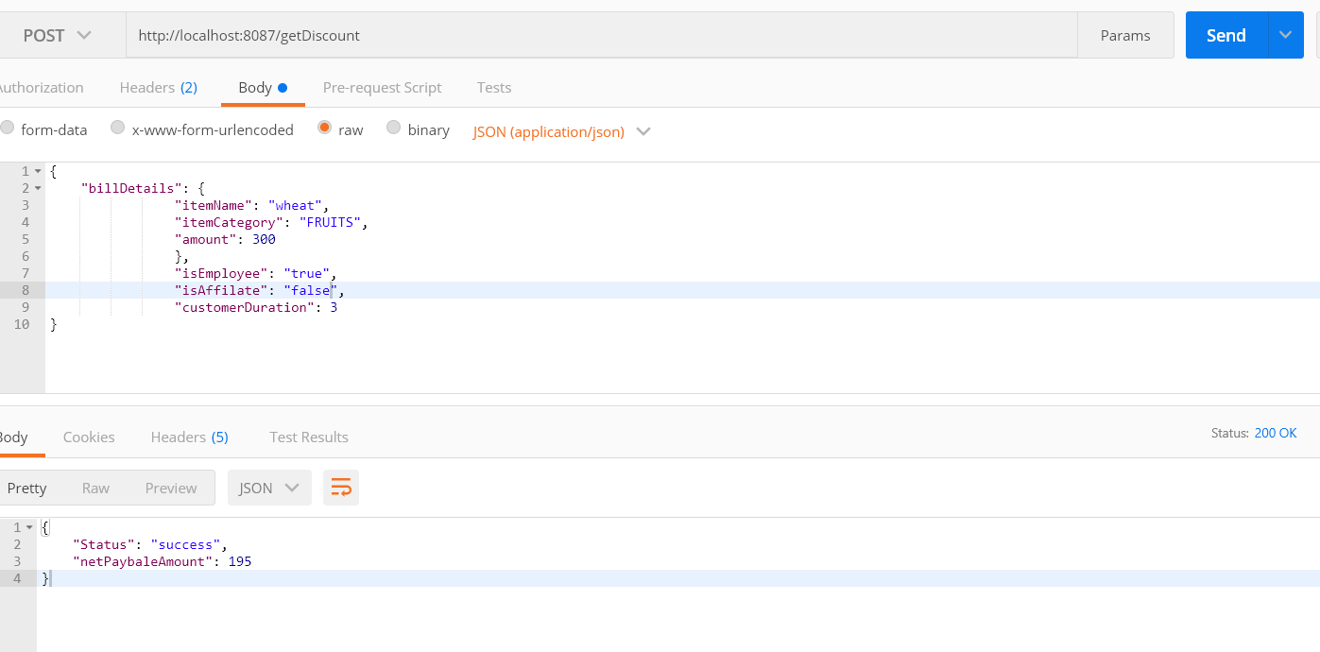

1. **With Grocery Category:**

